**Visual Studio Code on Coursera**

In addition to having Visual Studio Code installed on your own computer, in this course and throughout this program, you'll have the opportunity to work in Visual Studio Code right here on Coursera!

As you progress through the course, you'll be able to write code in hands-on activities called **Labs**. In these labs you'll be able to open Visual Studio Code and start writing code without ever leaving the course.



**How to get started working on Labs**

The Labs contain instructions explaining the coding task.

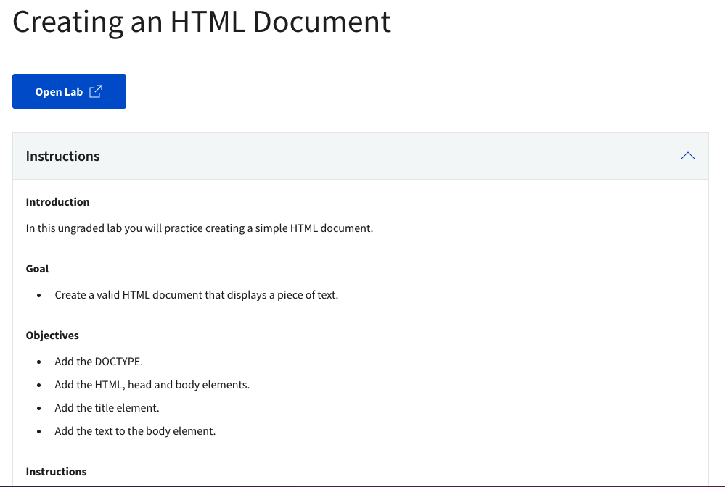

When you click the button to open the lab, a new tab will open with Visual Studio Code already setup and ready for you to start writing code!

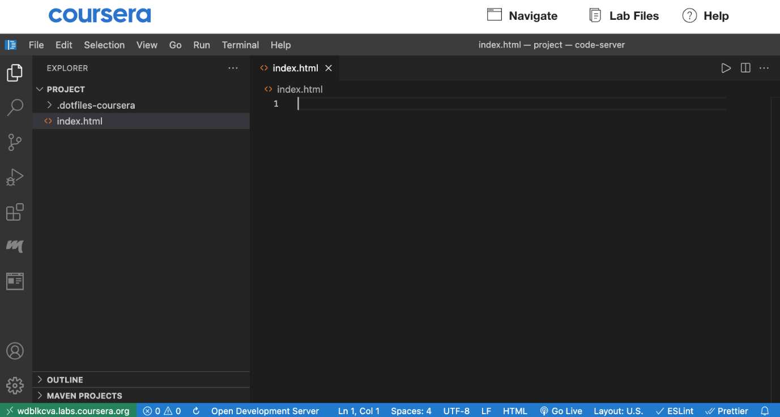

You'll see all the files for the lab in the Project folder in the left sidebar.

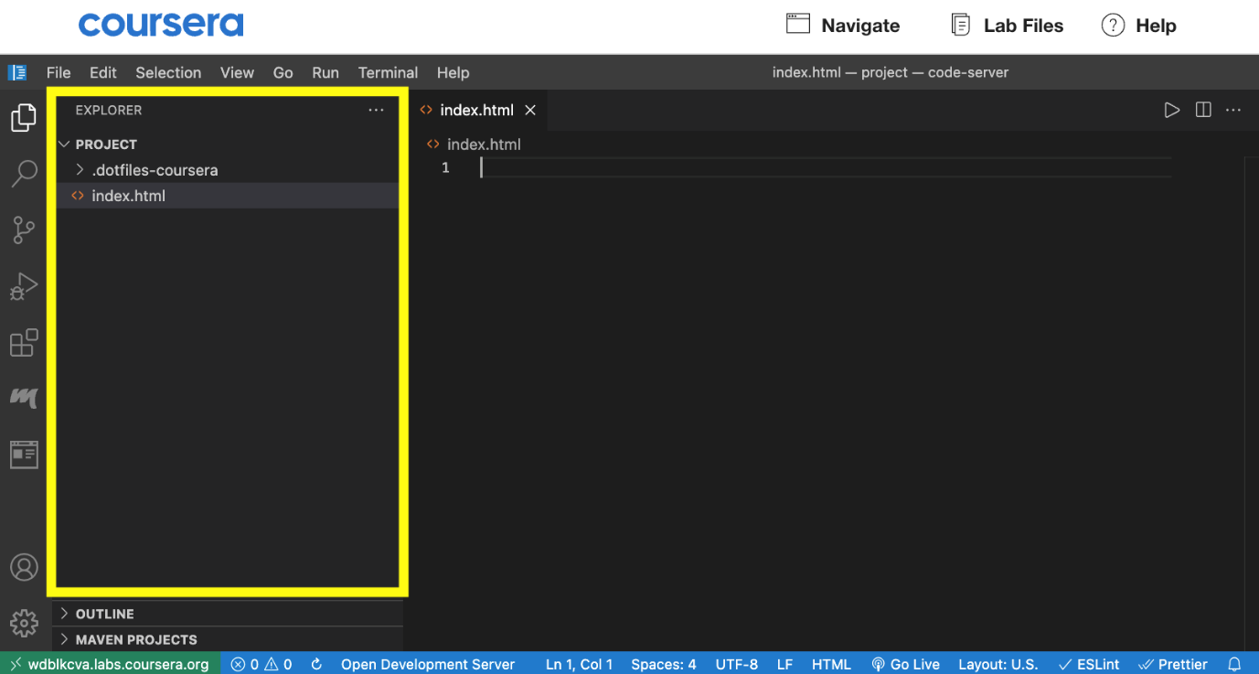

And the large editor area where you write your code for the lab.

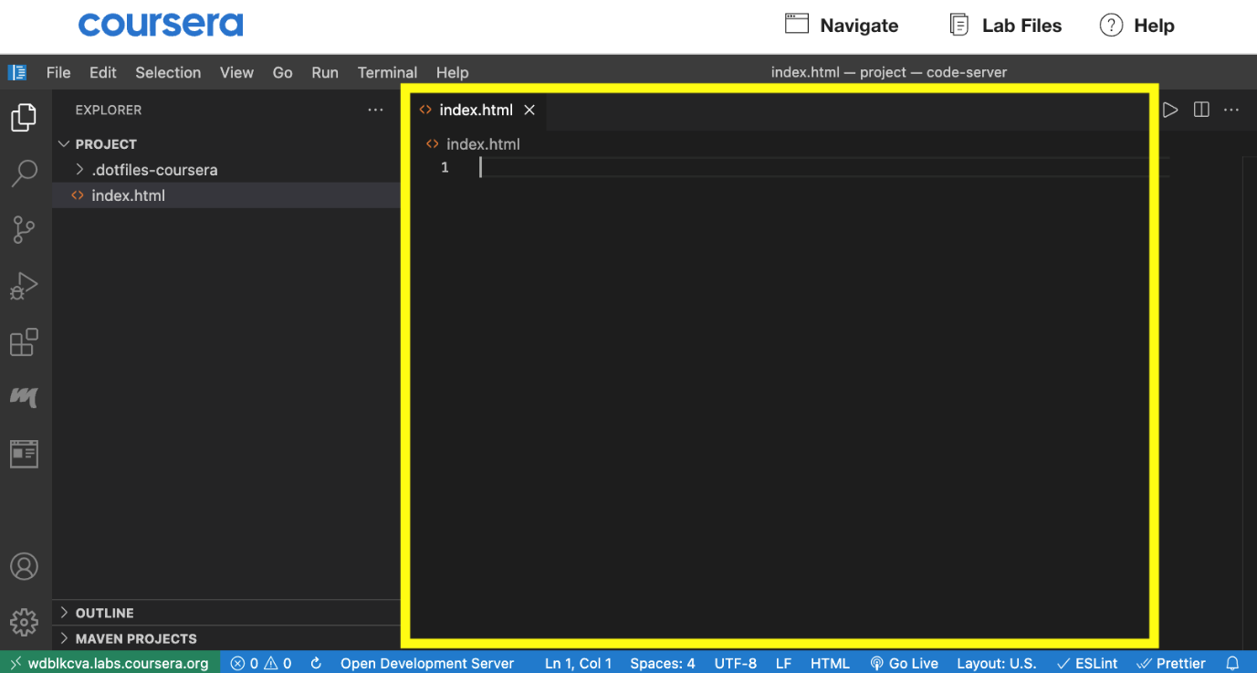

All **Lab** exercises will include two important files. A **README.md** file which contains instructions for using Visual Studio Code and most importantly, how to run and view the output of your code. The README.md file is the same for every Lab. There will also be an **instructions.md** file which provides specific instructions for each Lab.

These files may looking a little confusing at first. They're written using a language called Markdown. Markdown is just used to add formatting to text elements. Don't worry, you don't have to know anything about Markdown. If you open these files in **Preview** you'll just see the formatted output and they'll look totally normal.

You'll also likely see quite a few files and folders when you open in the Lab. Many of the files and folders you'll be able to ignore. To get started, look at the **instructions.md** file and it will explain which file or files you'll be working in.

**Working in the Terminal**

For Labs in some courses, you may need to use a tool called the Terminal from time to time to complete course activities. You can open this by selecting the **Terminal** option in the upper Visual Studio Code toolbar.

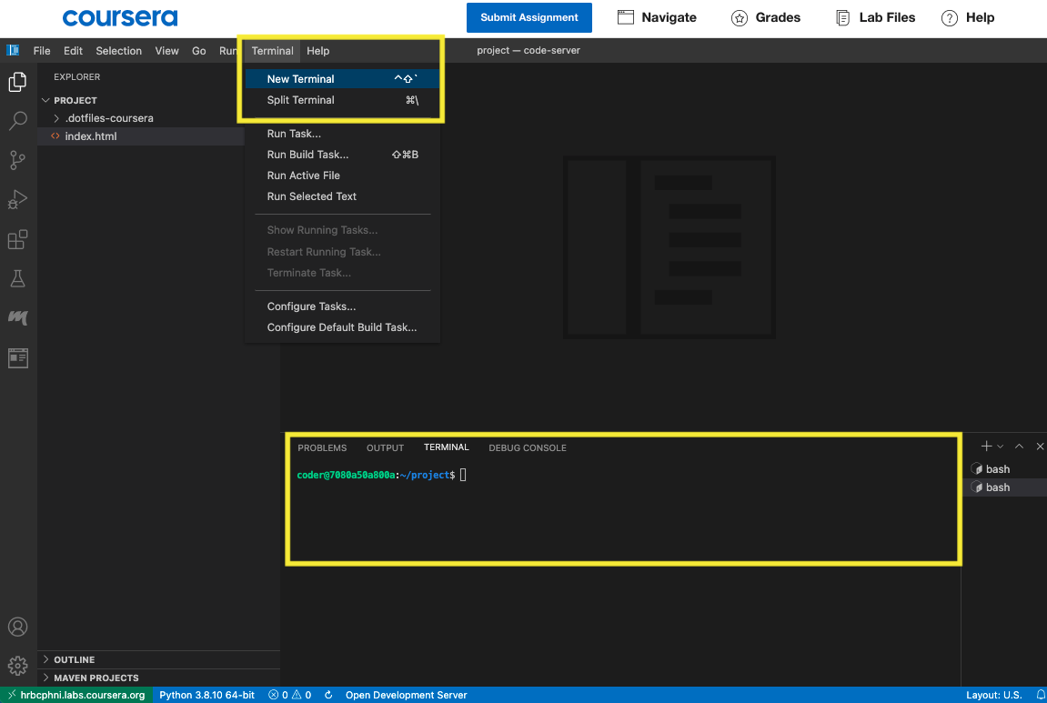

**How to download files from your Visual Studio Code Lab to your local device**

1. Select the **Lab Files** button in your Lab Toolbar.

2. You'll be able to download your full workspace, specific folders, or individual files through the checkbox selection tool.

3. After you've selected these files, use the **Download** link to download your files to your local device.

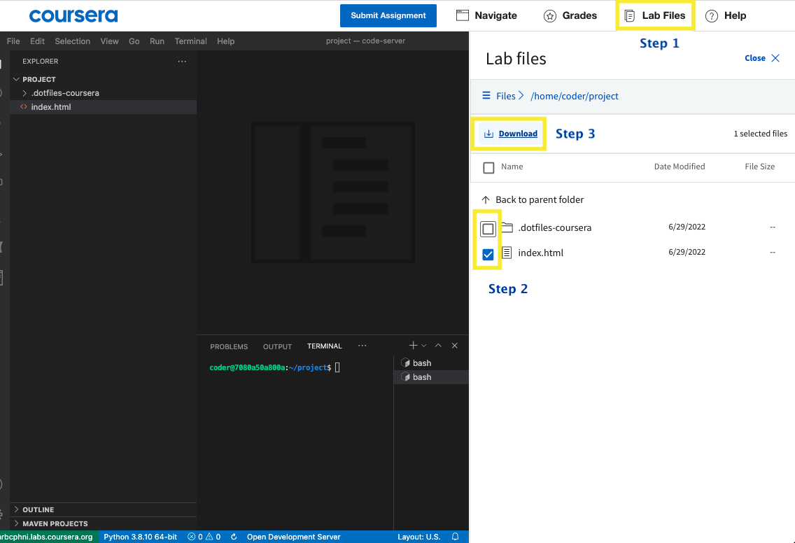

**How to upload local files to your Visual Studio Code Lab**

If you'd like to upload your course files from your local device to your Visual Studio Code lab, **drag and drop** your file from your local device into the Visual Studio Code file tree.

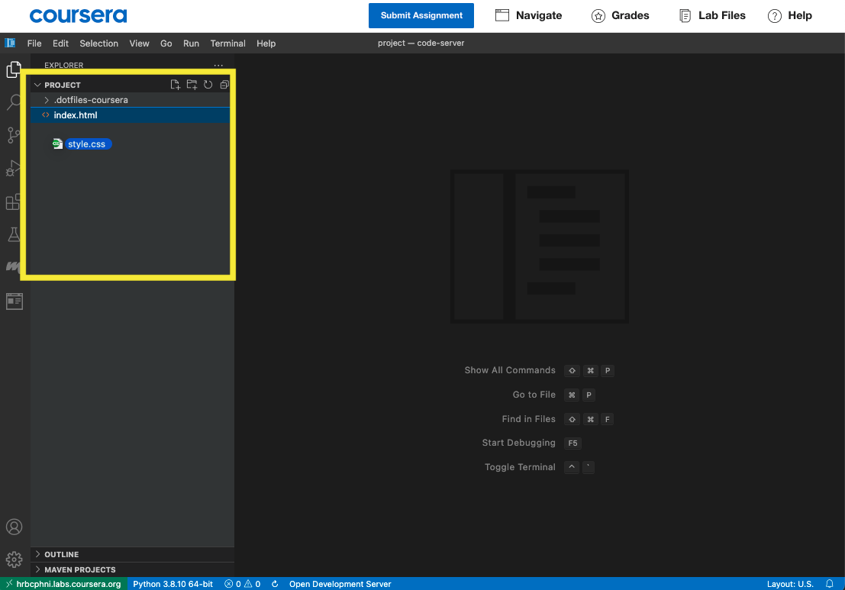

**How to get a fresh copy of course-provided starter files**

Your work will be saved and persist within your Visual Studio Code lab while you are enrolled in the course. If you'd like to get a fresh copy of the original instructor-provided files at any time, you can do this through the **Lab Help** option in your Lab Toolbar. Don't worry - your original work and files will still remain in your lab until you personally remove or delete them, even when refreshing your files through the steps below.

1. First rename your original files to something like *[yourfilename] [original].[your file extension]`.* You can do this by right-clicking on your file in the Visual Studio Code file tree, selecting **Rename**, and providing a new file name.

* For example for index.html, this could be renamed to *`index [original].html`*

2. Select **Lab Help** from your Lab Toolbar and then select **Get latest version.**

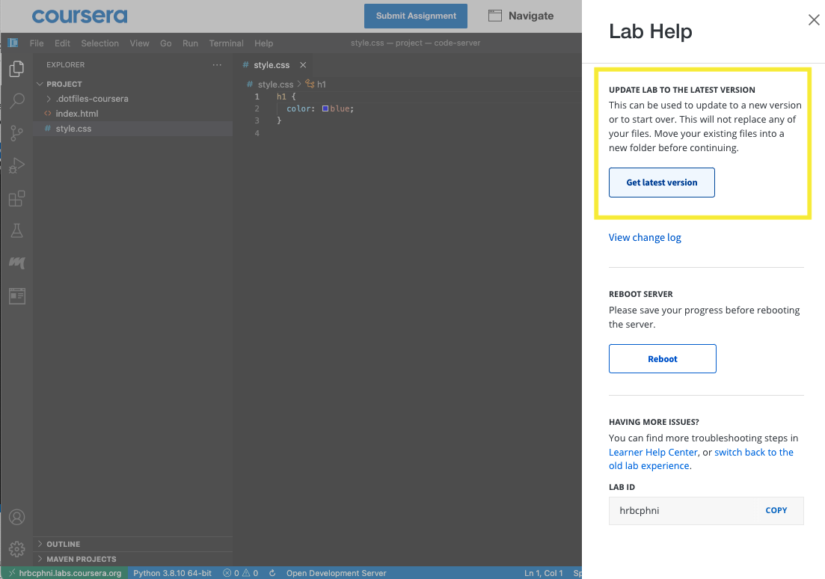

3. You should nowsee a fresh copy of the original instructor-provided files in your lab, in addition to your own (renamed) files.